**Project Report Format**

**1. INTRODUCTION**

1.1 Project Overview

1.2 Purpose

**2. IDEATION PHASE**

2.1 Problem Statement

2.2 Empathy Map Canvas

2.3 Brainstorming

**3. REQUIREMENT ANALYSIS**

3.1 Customer Journey map

3.2 Solution Requirement

3.3 Data Flow Diagram

3.4 Technology Stack

**4. PROJECT DESIGN**

4.1 Problem Solution Fit

4.2 Proposed Solution

4.3 Solution Architecture

**5. PROJECT PLANNING & SCHEDULING**

5.1 Project Planning

**6. FUNCTIONAL AND PERFORMANCE TESTING**

6.1 Performance Testing

**7. RESULTS**

7.1 Output Screenshots

**8. ADVANTAGES & DISADVANTAGES**

**9. CONCLUSION**

**10. FUTURE SCOPE**

**11. APPENDIX**

Source Code(if any)

Dataset Link

GitHub & Project Demo Link

**1.INTRODUCTION**

**1.1 Project Overview:**

ShopSmart: Your Digital Grocery Store Experience is a full-stack web application developed using the MERN stack, which includes React.js for the frontend, Node.js and Express.js for the backend, and MongoDB with Mongoose for the database. The application is designed to provide a seamless and user-friendly online grocery shopping experience. It allows customers to browse products across different categories, view detailed product information, add items to a shopping cart, and securely complete the checkout process. The system also includes an administrative interface where admins can manage products, monitor orders, and oversee user accounts. The application follows a structured architecture with clear separation between frontend, backend, and database layers, ensuring maintainability, scalability, and security. Role-based access control is implemented to differentiate between user and admin functionalities, and authentication is handled securely using encrypted passwords and token-based authorization.

**1.2 Purpose:**

The purpose of the ShopSmart project is to develop a user-friendly digital grocery shopping platform that allows customers to browse products, manage their cart, and place orders securely. The system also provides administrative control for managing products, users, and orders efficiently. Additionally, the project aims to demonstrate practical implementation of full-stack development using the MERN stack with secure authentication and structured architecture.

**Key objectives of the system include:**

* To design and develop a responsive and intuitive grocery web application using React.js.
* To implement secure user authentication and role-based access control using JWT.
* To create RESTful APIs using Node.js and Express.js for handling business logic.
* To design and manage MongoDB database schemas using Mongoose.
* To implement complete product management, cart management, and order processing features.
* To provide an admin dashboard for managing products, users, and orders.
* To ensure data security, proper error handling, and clean project structure.

**2.IDEATION PHASE**

**2.1 Problem Statement:**

In today’s fast-paced lifestyle, many customers find it difficult to visit physical grocery stores due to time constraints and inconvenience. Traditional shopping methods lack efficient digital management for product browsing, order tracking, and secure transactions. Small and medium grocery businesses also face challenges in managing inventory, customer data, and order processing effectively. Therefore, there is a need for a secure, user-friendly, and efficient digital grocery platform that simplifies online shopping while providing proper administrative control and system management.

**Problem Statement -1:**

|  |  |
| --- | --- |
| I am | a grocery customer |
| I’m trying to | buy daily grocery items online quickly and conveniently |
| But | I cannot easily find all products in one place with clear stock availability |
| Because | many local stores don’t provide a proper digital platform with real-time updates |
| Which makes me feel | frustrated and time-wasted |

**Problem** **Statement -2:**

|  |  |
| --- | --- |
| I am | a store administrator |
| I’m trying to | manage products, inventory, and customer orders efficiently |
| But | I struggle to track stock levels and customer bookings manually |
| Because | there is no centralized online management system |
| Which makes me feel | overwhelmed and stressed |

|  |  |  |  |  |  |
| --- | --- | --- | --- | --- | --- |
| **Problem Statement (PS)** | **I am** | **I’m trying to** | **But** | **Because** | **Which makes me feel** |
| PS-1 | A customer | Find quality grocery products at good prices | It is hard to compare products and availability | Many stores don’t provide clear stock and price details | Confused and uncertain |
| PS-2 | An admin | Monitor customer orders and sales | Tracking orders across different platforms is confusing | Data is not organized in one place | Stressed |

**2.2 Empathy Map:**

**User: - Naveen Lukalapu** (A working professional buying groceries online.)

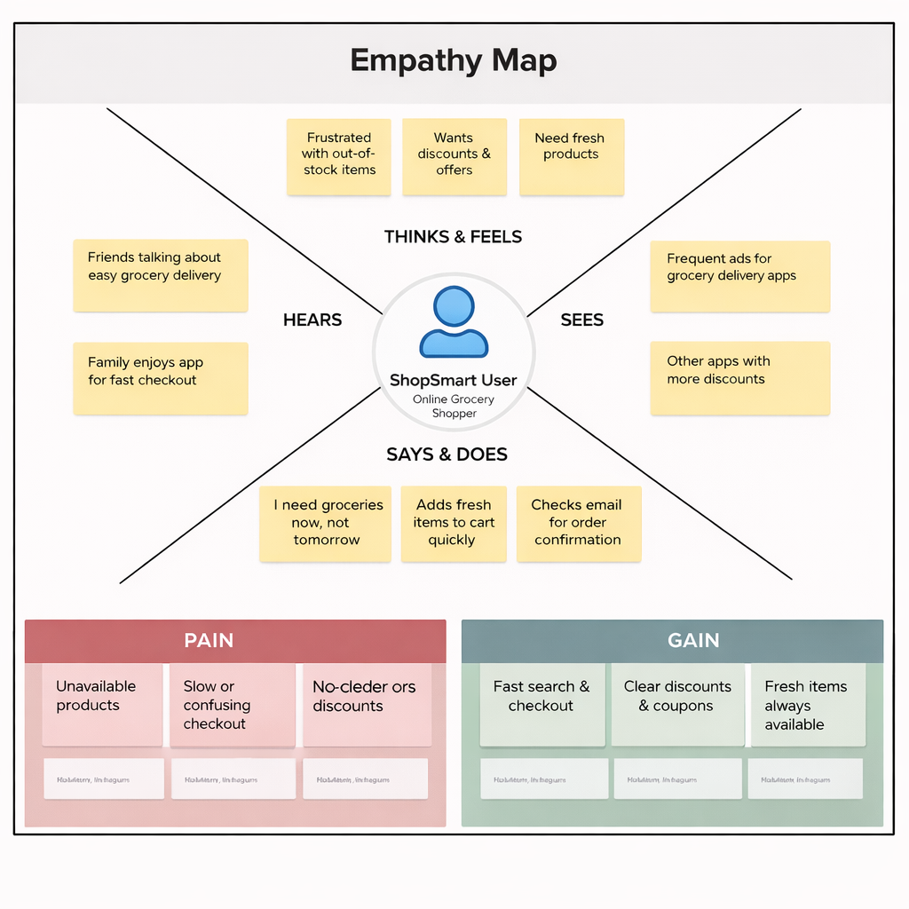

**2.2 Brainstorm & Idea Prioritization:-**

**Step-1: Team Gathering, Collaboration and Select the Problem Statement**

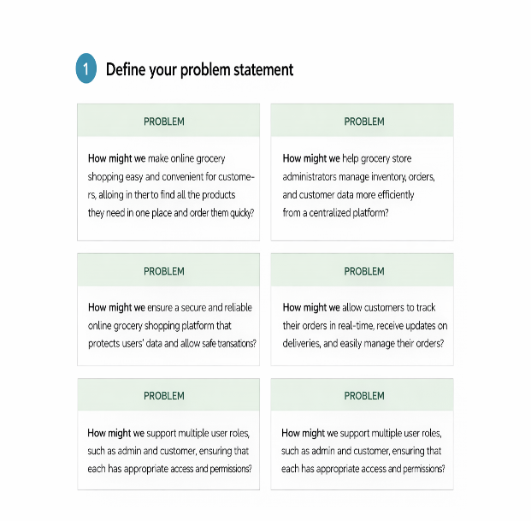

**Step-2: Brainstorm, Idea Listing and Grouping**

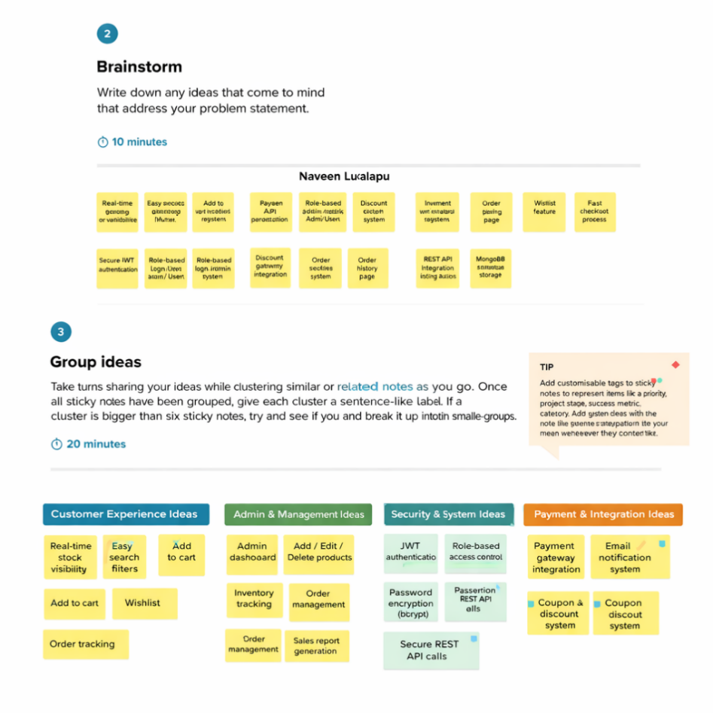

**Step-3: Idea Prioritization**

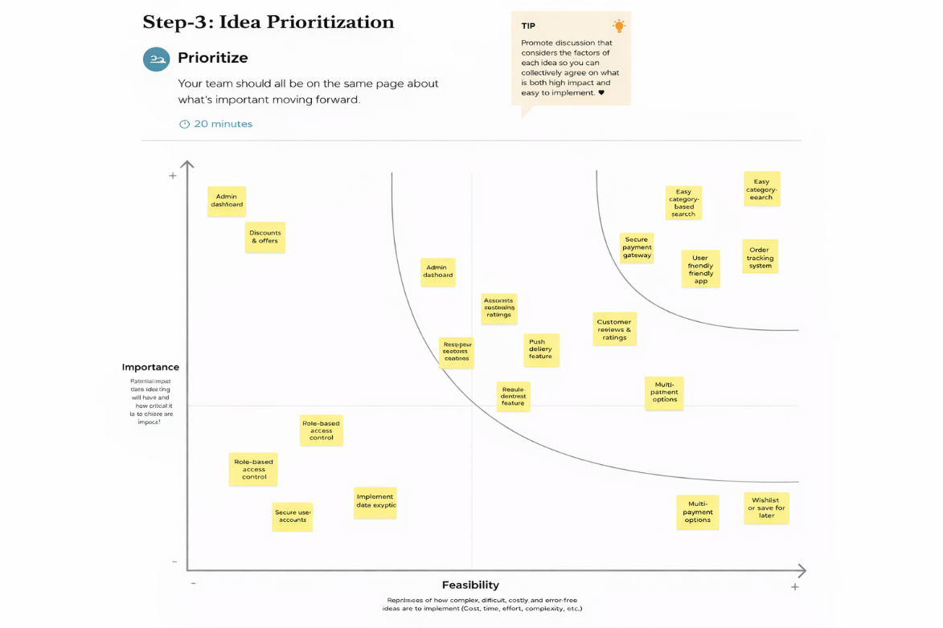

**3. REQUIREMENT ANALYSIS**

**3.1 Customer Journey map: -**

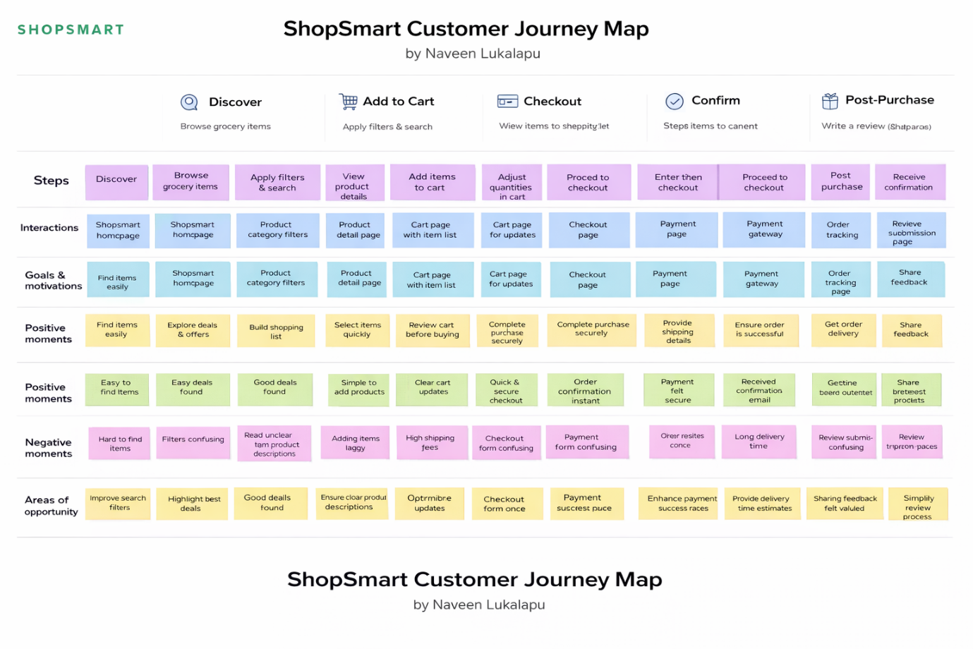

**3.2 Solution Requirement**

**Functional Requirements:**

Following are the functional requirements of the proposed solution.

|  |  |  |
| --- | --- | --- |
| **FR No.** | **Functional Requirement (Epic)** | **Sub Requirement (Story / Sub-Task)** |
| FR-1 | User Registration | Registration through Form (Name, Email, Password) Password Encryption (bcrypt) Validation of Email & Password |
| FR-2 | User Login & Authentication | Login using Email & Password JWT Token Generation Role-based Login (Admin/User) |
| FR-3 | Admin Login | Predefined Admin Credentials (Backend Only) Admin Authentication via JWT |
| FR-4 | Product Management (Admin) | Add New Product Edit Product Details Delete Product Manage Stock Quantity |
| FR-5 | Product Browsing (User) | View Product List Search Products Filter by Category View Product Details |
| FR-6 | Cart Management | Add Item to Cart Update Quantity Remove Item View Cart Summary |
| FR-7 | Order Management | Place Order Calculate Total Amount Reduce Product Stock After Order Cancel Order View Order History |
| FR-8 | Payment Handling | Select Payment Method (COD / Online) Payment Status Update |
| FR-9 | Review & Rating | Add Product Review View Reviews |
| FR-10 | Admin Dashboard | View All Users View All Orders Generate Sales Report |

**Non-functional Requirements:**

Following are the non-functional requirements of the proposed solution.

|  |  |  |
| --- | --- | --- |
| **FR No.** | **Non-Functional Requirement** | **Description** |
| NFR-1 | **Usability** | The application must have a clean, responsive UI for desktop and mobile devices. |
| NFR-2 | **Security** | Passwords must be encrypted; JWT authentication must secure protected routes. |
| NFR-3 | **Reliability** | System should correctly process orders without data loss. |
| NFR-4 | **Performance** | API response time should be less than 2 seconds under normal load. |
| NFR-5 | **Availability** | Application should be accessible 24/7 with minimal downtime. |
| NFR-6 | **Scalability** | System should handle increasing number of users and products efficiently. |

**3.3 Data Flow Diagram: -**

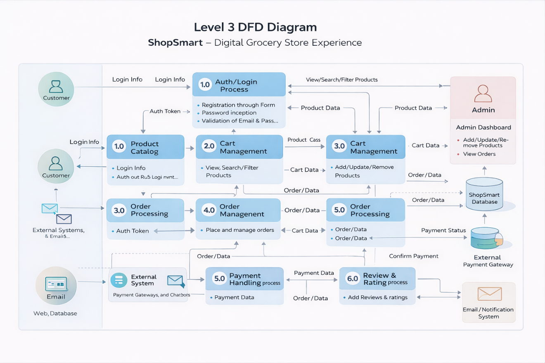

**3.4 Technology Stack: -**

**Technical Architecture: -**

The ShopSmart application follows a 3-Tier Client–Server Architecture:

• **Presentation Layer (Frontend):** React.js provides an interactive and responsive web interface where users can browse products, manage their cart, place orders, and track purchases, while admins can manage products and monitor orders.

• **Application Layer (Backend):** Node.js and Express.js handle REST API requests, user authentication, role-based access control, product management, cart operations, and order processing logic.

• **Data Layer (Database):** MongoDB, integrated using Mongoose, stores user accounts, product details, cart data, and order records in structured collections.

The frontend communicates with backend REST APIs using Axios, and JWT-based authentication secures protected routes for both users and admins. Passwords are encrypted using bcrypt to ensure secure credential storage.

**Table-1: Components & Technologies:**

|  |  |  |  |
| --- | --- | --- | --- |
| **S. No** | **Component** | **Description** | **Technology** |
|  | User Interface | Web application where users and admin interact (Product browsing, cart, dashboard) | React.js, HTML5, CSS3, JavaScript |
|  | Application Logic-1 | Authentication & Authorization (Login, Register, JWT validation) | Node.js, Express.js, JWT, bcrypt |
|  | Application Logic-2 | Product Catalog Management (CRUD operations for products) | Express.js, REST APIs, Node.js |
|  | Application Logic-3 | Cart & Order Processing Logic | Node.js , Express.js, |
|  | Database | Stores Users, Products, Cart, Orders, Reviews | MongoDB, Mongoose |
|  | Cloud Database | Database hosting in cloud | MongoDB Atlas |
|  | File Storage | Product images storage | Cloudinary / Local File System |
|  | External API-1 | |  | | --- | |  |  |  | | --- | | Payment Gateway Integration | | Stripe API / Razorpay API |
|  | External API-2 | Email Notification Service | Nodemailer / SendGrid |
|  | Machine Learning Model | Product Recommendation (future enhancement) | Recommendation Algorithm |
|  | Infrastructure (Server / Cloud) | Application deployment | Local Server (Development), Render / Vercel / AWS (Production) |

**Table-2: Application Characteristics:**

| **S. No** | **Characteristics** | **Description** | **Technology** |
| --- | --- | --- | --- |
|  | Open-Source Frameworks | Frontend and Backend frameworks used | React.js, Node.js, Express.js |
|  | Security Implementations | Password hashing, JWT authentication, role-based access control | bcrypt, JWT, CORS, Helmet |
|  | Scalable Architecture | 3-Tier Architecture (Frontend – Backend – Database) | REST Architecture, MongoDB |
|  | Availability | |  | | --- | |  |  |  | | --- | | Hosted on cloud with uptime reliability | | MongoDB Atlas, Cloud Hosting |
|  | Performance | Fast API response and optimized queries | Express Middleware, Indexed MongoDB |

**4. PROJECT DESIGN**

**4.1 Problem Solution Fit : -**

ShopSmart is designed to simplify grocery shopping for busy individuals by providing a seamless digital experience. It addresses the inefficiencies of traditional grocery shopping and fragmented online platforms by offering real-time product availability, secure payments, and centralized management for both users and admins.

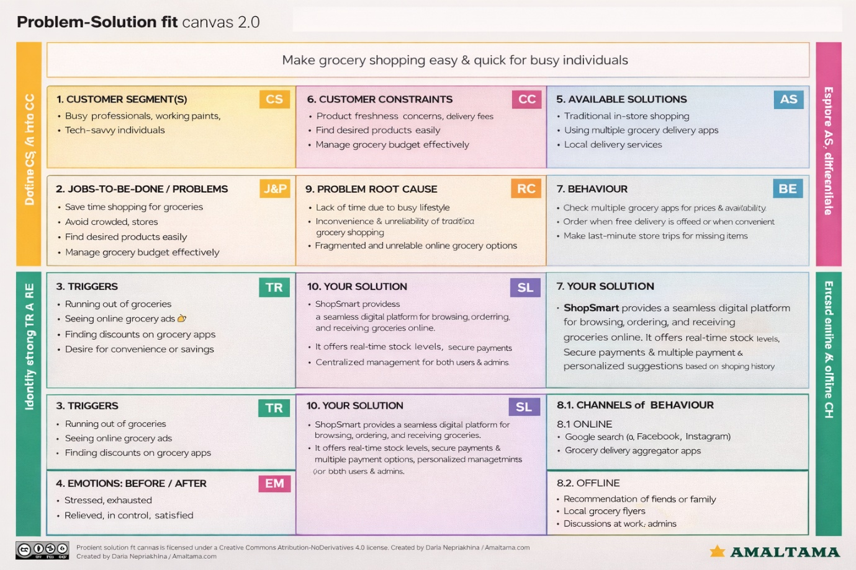

**4.2 Proposed Solution : -**

|  |  |  |
| --- | --- | --- |
| **S.No** | **Parameter** | **Description** |
| 1 | **Problem Statement (Problem to be solved)** | Busy individuals and working families face difficulty in purchasing groceries due to lack of time, long queues, limited product availability visibility, and fragmented online grocery services. There is no centralized, reliable, and user-friendly platform that ensures real-time stock updates, secure payments, and smooth order management. |
| 2 | **Idea / Solution Description** | ShopSmart is a full-stack digital grocery web application built using MERN stack (React, Node, Express, MongoDB). It allows users to browse products, add items to cart, place orders, and track deliveries seamlessly. It provides real-time stock visibility, secure authentication (JWT-based), role-based access (Admin & User), centralized product management, and smooth checkout process. |
| 3 | **Novelty / Uniqueness** | • Role-based access system (Admin controlled backend management)  • Real-time inventory updates  • Centralized product & order management  • Secure JWT authentication  • Clean UI with responsive design  • Scalable backend architecture using REST APIs |
| 4 | **Social Impact / Customer Satisfaction** | • Saves time for working professionals and families  • Reduces crowding in physical stores  • Enables convenient shopping from home  • Ensures secure transactions and data privacy  • Provides personalized and smooth user experience |
| 5 | **Business Model (Revenue Model)** | • Commission on product sales  • Delivery service charges  • Featured product promotions for sellers  • Subscription model for premium delivery benefits  • Advertisement placements for grocery brands |
| 6 | **Scalability of the Solution** | • Built on scalable MERN stack architecture  • MongoDB supports large-scale data handling  • Can be deployed on cloud platforms (AWS, Azure, etc.)  • Supports horizontal scaling and microservice expansion  • Can be expanded to mobile application in future |

**4.3 Solution Architecture : -**

Solution architecture defines the overall structure of the ShopSmart grocery web application and explains how different components interact with each other. It bridges the gap between business requirements and technical implementation by organizing the frontend, backend, database, and external services in a structured manner.

The architecture ensures secure communication between users and the system, manages product and order processing efficiently, and supports scalability and performance. It also defines how authentication, APIs, database operations, and third-party integrations (like payment gateways) work together to deliver a seamless grocery shopping experience.

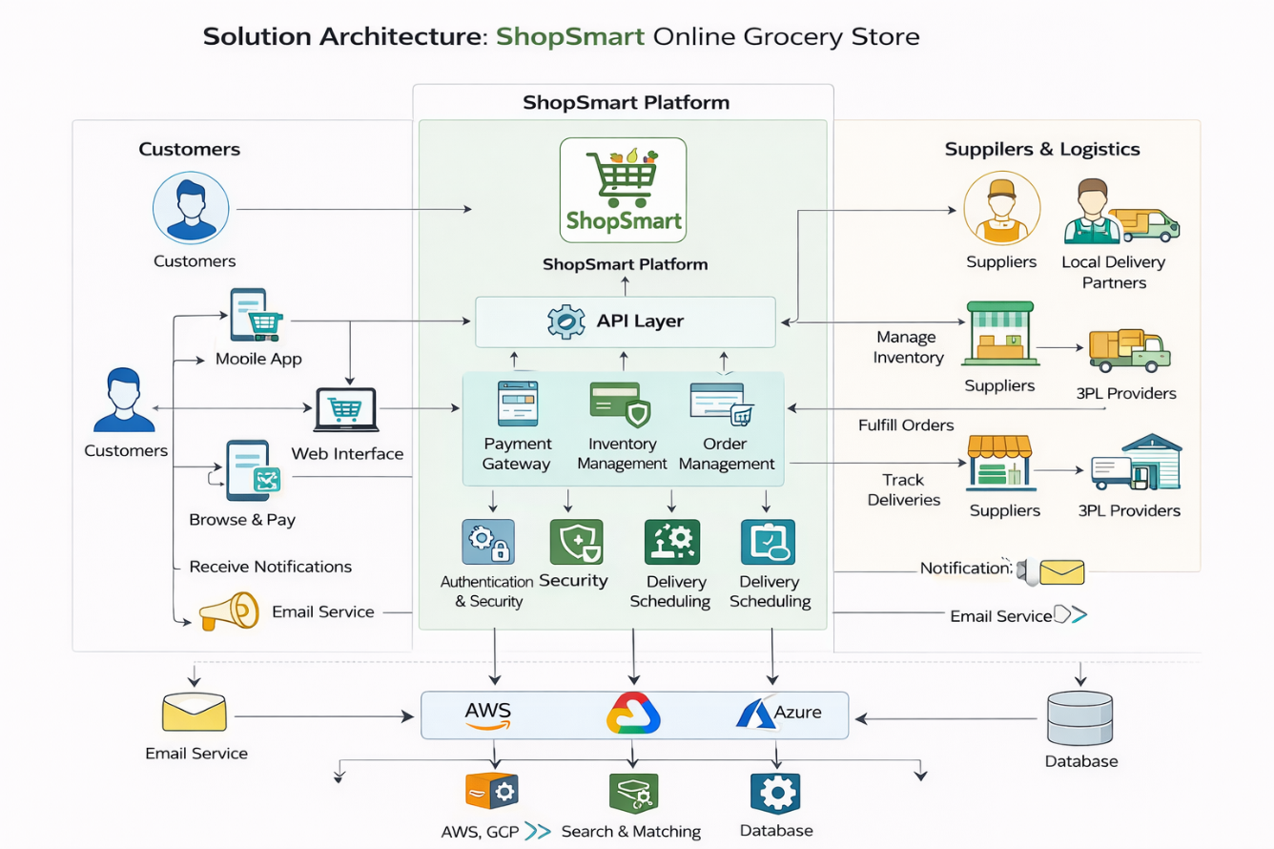

**5. PROJECT PLANNING & SCHEDULING**

**5.1 Project Planning : -**

**Product Backlog & Sprint Planning (ShopSmart)**

|  |  |  |  |  |  |
| --- | --- | --- | --- | --- | --- |
| **Sprint** | **Functional Requirement (Epic)** | **User Story No** | **User Story / Task** | **Story Points** | **Priority** |
| Sprint-1 | Authentication | US-1 | User can register with email & password | 3 | High |
| Sprint-1 | Authentication | US-2 | User can login securely | 2 | High |
| Sprint-1 | Admin | US-3 | Admin login with predefined credentials | 2 | High |
| Sprint-1 | UI | US-4 | Create homepage & navigation | 3 | Medium |
| Sprint-1 | UI | US-5 | Display product list | 5 | High |
| **Sprint-1 Total** |  |  |  | **15** |  |
| **Sprint-2** | Functional Requirement | User Story No | User Story | **Story Points** | Priority |
| **Sprint-2** | Product | US-6 | Admin add product | 5 | High |
| **Sprint-2** | Product | US-7 | Admin edit/delete product | 5 | High |
| **Sprint-2** | Product | US-8 | Product details page | 4 | Medium |
| **Sprint-2** | Search | US-9 | Product search/filter | 6 | Medium |
| **Sprint-2 Total** |  |  |  | **20** |  |
| **Sprint-3** | Functional Requirement | User Story No | User Story | **Story Points** | Priority |
| **Sprint-3** | Cart | US-10 | Add to cart | 5 | High |
| **Sprint-3** | Cart | US-11 | Update/remove cart items | 5 | High |
| **Sprint-3** | Order | US-12 | Checkout process | 6 | High |
| **Sprint-3** | Order | US-13 | Order placement | 4 | High |
| **Sprint-3 Total** |  |  |  | **20** |  |
| **Sprint-4** | Functional Requirement | User Story No | User Story | **Story Points** | Priority |
| **Sprint-4** | Orders | US-14 | Order history | 5 | Medium |
| **Sprint-4** | Orders | US-15 | Admin view all orders | 5 | High |
| **Sprint-4** | Payment | US-16 | Payment integration | 6 | Medium |
| **Sprint-4** | Email | US-17 | Email confirmation | 4 | Medium |
| **Sprint-4 Total** |  |  |  | **20** |  |

**Sprint Tracker (Velocity Table)**

|  |  |  |  |  |  |  |
| --- | --- | --- | --- | --- | --- | --- |
| **Sprint** | **Total Story Points** | **Duration** | **Start** | **End (Planned)** | **Completed** | **Actual** |
| Sprint-1 | 20 | 7 days | Day 1 | Day 7 | 20 | Day 7 |
| Sprint-2 | 20 | 7 days | Day 8 | Day 14 | 18 | Day 14 |
| Sprint-3 | 20 | 7 days | Day 15 | Day 21 | 16 | Day 21 |
| Sprint-4 | 20 | 7 days | Day 22 | Day 28 | 14 | Day 28 |

**Velocity Calculation**

Total completed story points = 20 + 18 + 16 + 14 = **68**

Number of sprints = 4

**Average Velocity = 68 / 4 = 17 story points per sprint**

If sprint duration = 7 days:

**Velocity per day = 17 / 7 ≈ 2.4 points/day**

**Burndown Chart :**

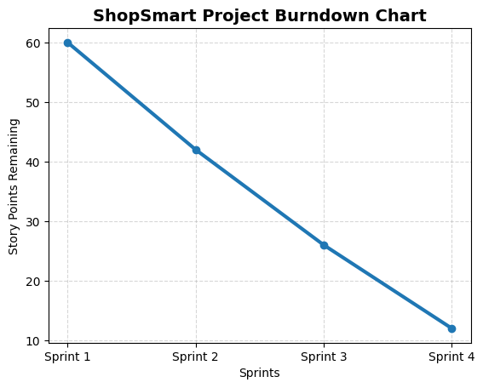

**6. FUNCTIONAL AND PERFORMANCE TESTING**

**6.1 Performance Testing**

**Test Scenarios & Results**

|  |  |  |  |  |  |
| --- | --- | --- | --- | --- | --- |
| **Test Case ID** | **Scenario (What to test)** | **Test Steps (How to test)** | **Expected Result** | **Actual Result** | **Pass/Fail** |
| FT-01 | User Registration | Enter valid & invalid user details | Valid registration succeeds; errors for invalid input | Registration works correctly | Pass |
| FT-02 | User Login | Enter correct & incorrect credentials | Login success for valid; error for invalid | Authentication works | Pass |
| FT-03 | Admin Login | Login with predefined admin credentials | Admin dashboard opens | Admin access granted | Pass |
| FT-04 | Product Listing | Load product page | Products display from DB | Products shown correctly | Pass |
| FT-05 | Add Product (Admin) | Add new product from admin panel | Product stored in DB & visible | Product added | Pass |
| FT-06 | Edit/Delete Product | Modify or remove product | DB updates & UI reflects | Update successful | Pass |
| FT-07 | Add to Cart | Click add-to-cart button | Item added to user cart | Cart updated | Pass |
| FT-08 | Update Cart | Change quantity/remove item | Cart recalculates total | Cart updates | Pass |
| FT-09 | Checkout Process | Place order with cart items | Order stored & cart cleared | Order placed | Pass |
| FT-10 | Order History | View past orders | User orders displayed | Orders shown | Pass |
| FT-11 | Payment Integration | Simulate payment selection | Payment status stored | Payment recorded | Pass |

**Performance Testing**

|  |  |  |  |  |  |
| --- | --- | --- | --- | --- | --- |
| **Test Case ID** | **Scenario** | **Test Steps** | **Expected Result** | **Actual Result** | **Pass/Fail** |
| PT-01 | Page Load Time | Load homepage/products | < 2 seconds | ~1.5 sec | Pass |
| PT-02 | API Response | Fetch products API | Fast response | Stable | Pass |
| PT-03 | Concurrent Users | Multiple users add cart | No crash | Stable | Pass |
| PT-04 | DB Query Speed | Search products | Quick retrieval | Fast | Pass |
| PT-05 | Order Processing Load | Multiple orders placed | Orders saved correctly | Stable | Pass |

**7. RESULTS**

**7.1 Output Screenshots**

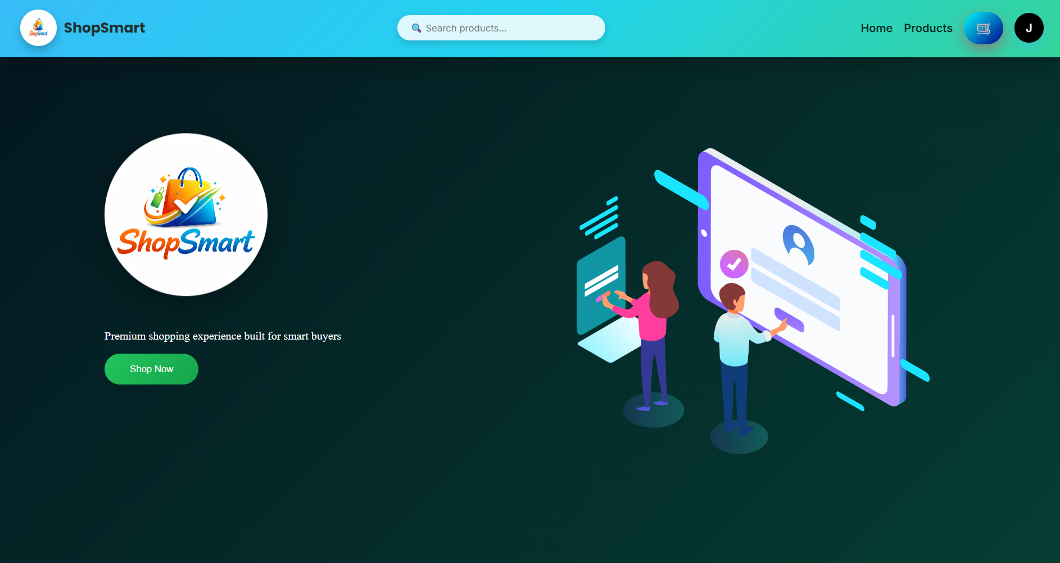

**Fig : User Home Page**

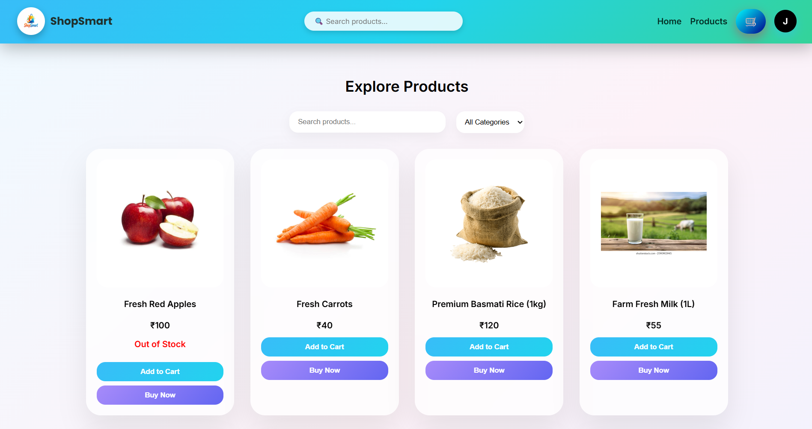

**Fig : User Products Page**

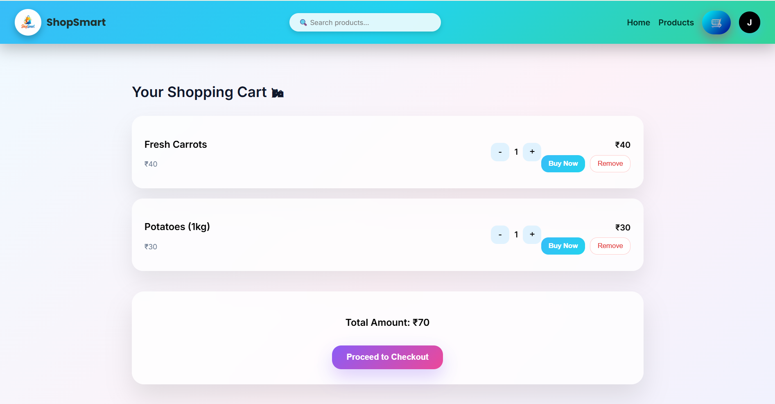

**Fig : User Cart Page**

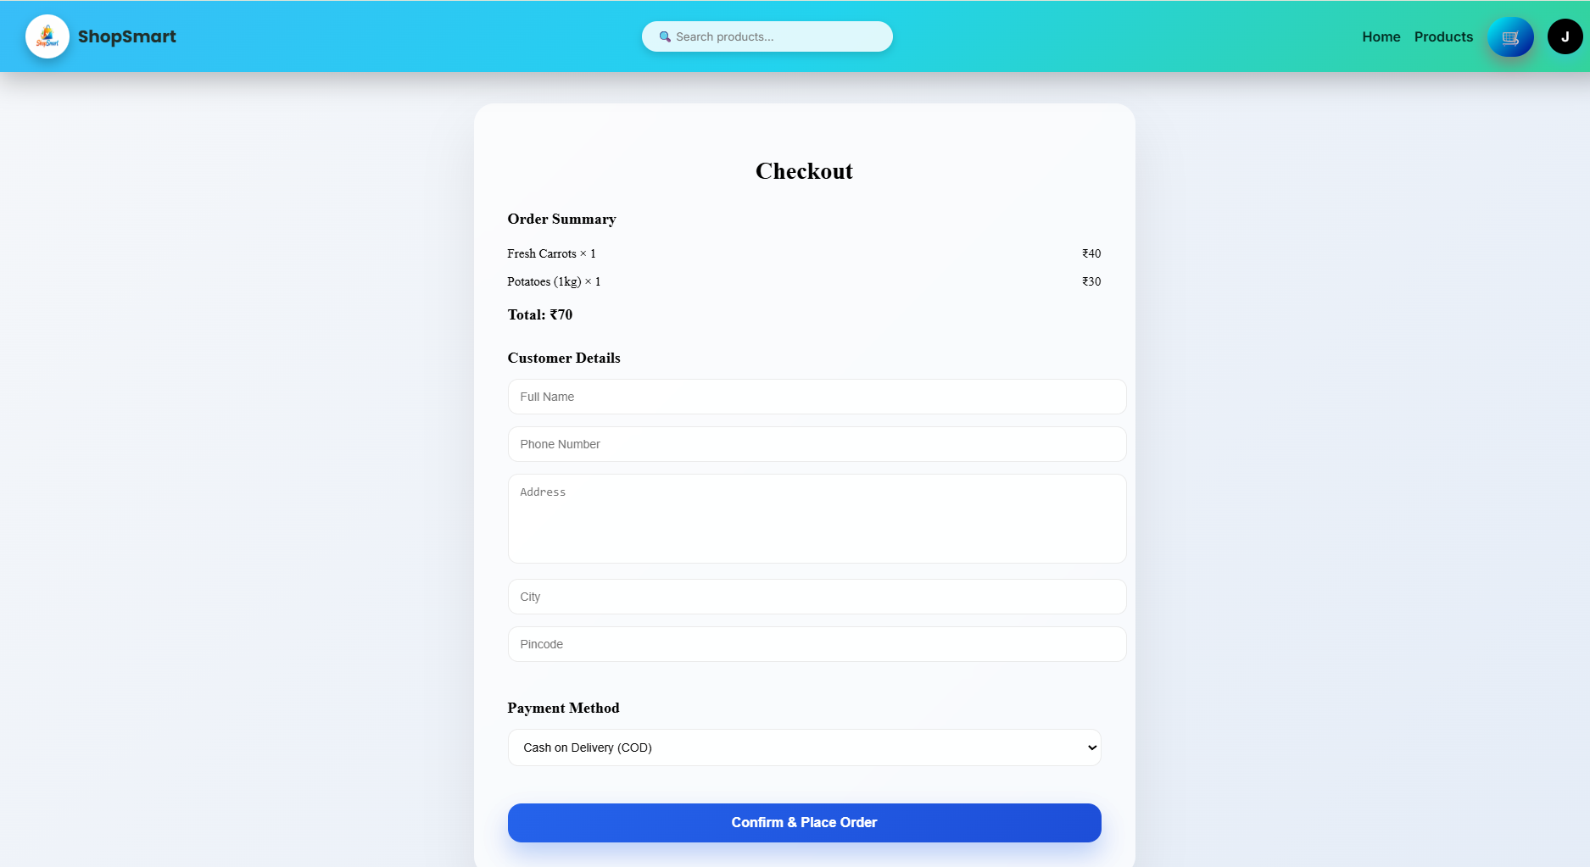

**Fig : User Checkout Page**

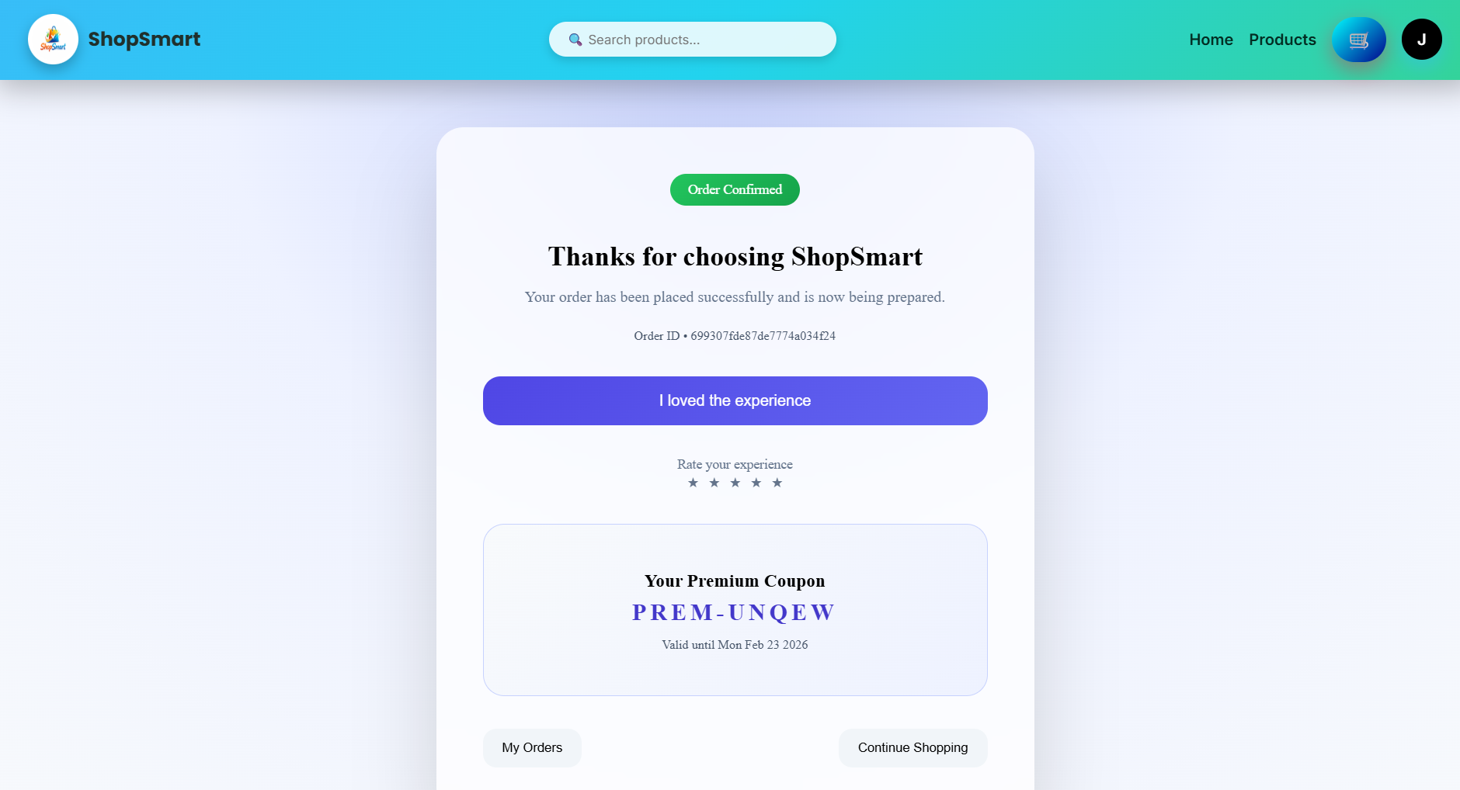

**Fig : User Order Confirmation Page**

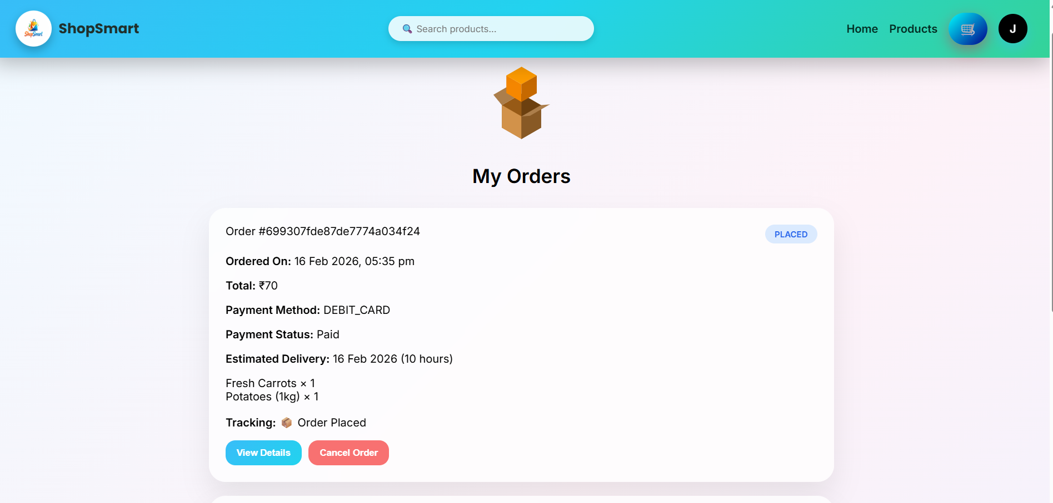

**Fig : User Orders Page**

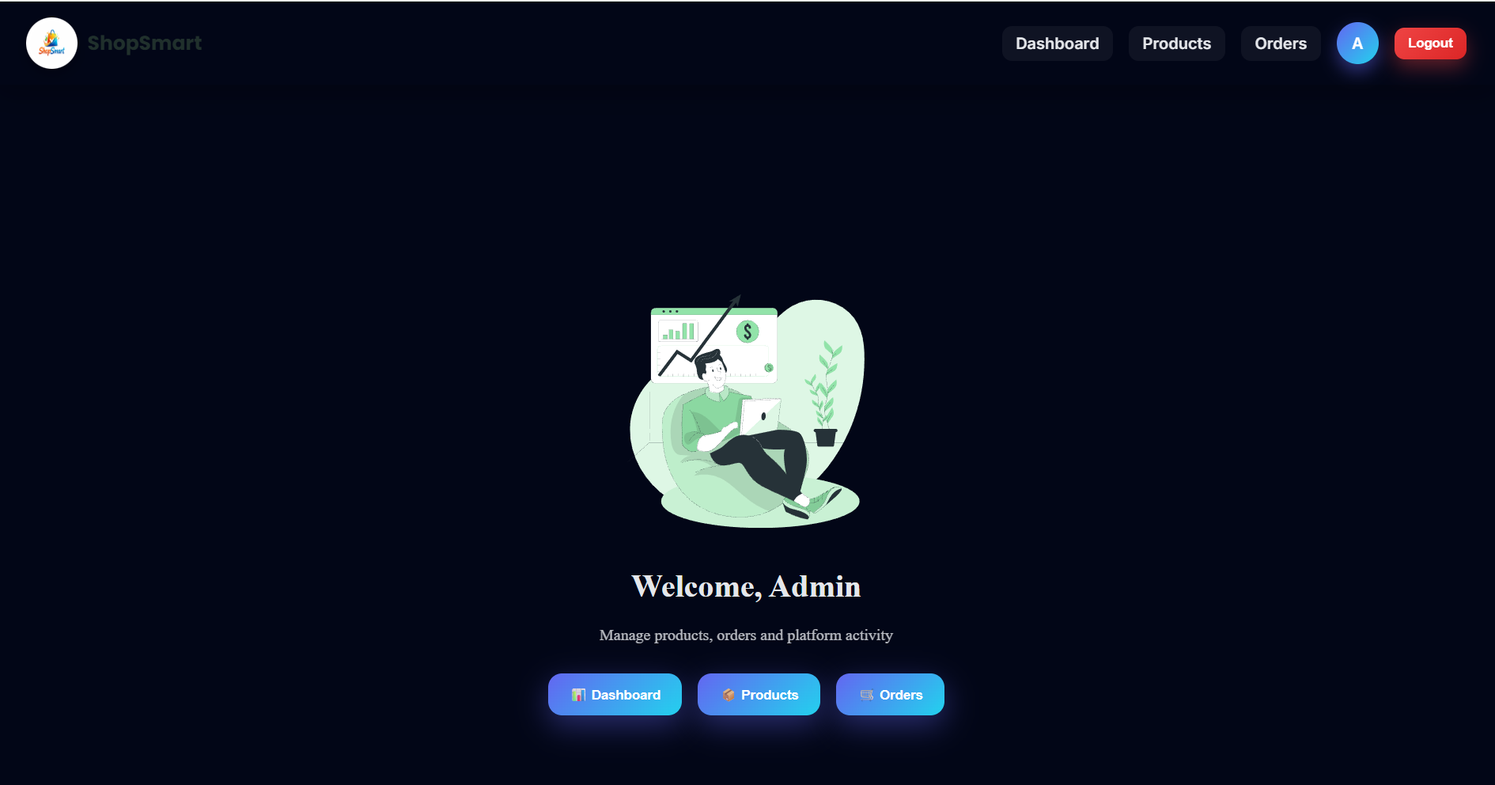

**Fig : Admin Home Page**

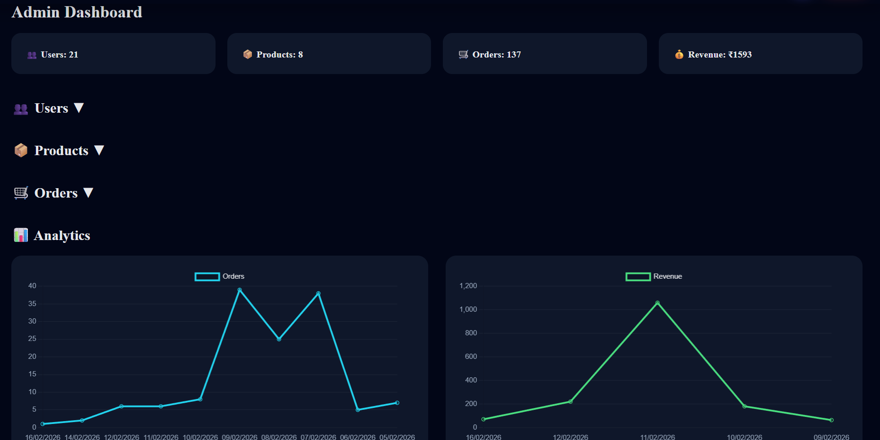

**Fig : Admin Dashboard Page**

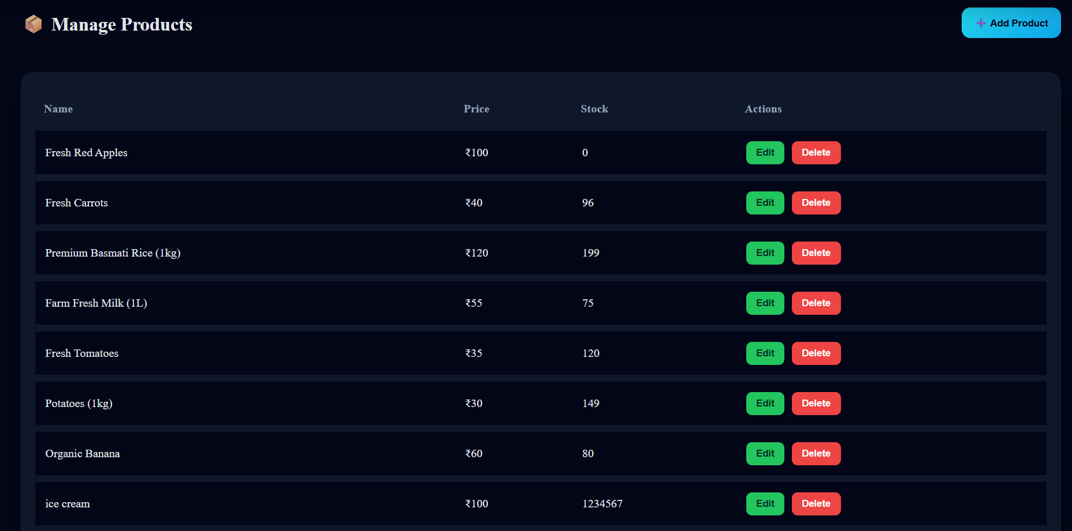

**Fig : Admin Products Page**

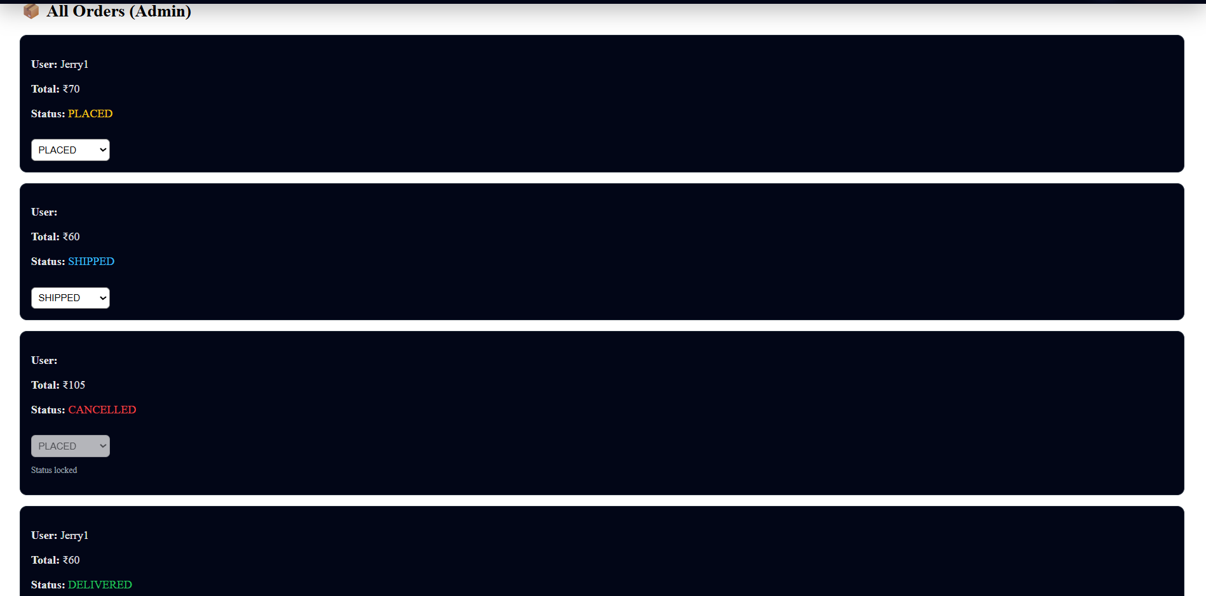

**Fig : Admin Orders Page**

**8. ADVANTAGES & DISADVANTAGES**

**Advantages of the ShopSmart Project**

1. **Full-Stack Implementation**  
   The project demonstrates complete frontend and backend integration using the MERN stack, providing real-world development experience.
2. **Role-Based Access Control**  
   Separate user and admin roles ensure secure access and proper authorization for sensitive operations like product and order management.
3. **Scalable Architecture**  
   The modular folder structure (MVC pattern in backend) makes the project easy to maintain and extend.
4. **Secure Authentication**  
   JWT-based authentication ensures stateless, secure communication between client and server.
5. **User-Friendly Shopping Flow**  
   Features like product search, category filtering, cart management, and checkout provide a smooth user experience.
6. **Admin Management System**  
   Admin dashboard enables efficient product CRUD operations and order status tracking.
7. **Academic and Practical Learning Value**  
   Covers authentication, APIs, database design, and frontend routing, making it a strong academic project.

**Disadvantages of the ShopSmart Project**

1. **No Real Payment Gateway Integration**  
   The system does not process real online payments, limiting production-level deployment.
2. **Basic UI/UX Design**  
   The interface focuses more on functionality than advanced professional design.
3. **Token Stored in Local Storage**  
   JWT stored in local storage may pose security risks in large-scale applications.
4. **Limited Scalability Optimization**  
   No caching, load balancing, or performance optimization techniques are implemented.
5. **No Real-Time Features**  
   Order updates and notifications are not real-time and require manual refresh.
6. **No Automated Testing Framework**  
   The project mainly uses manual testing instead of automated unit and integration testing tools.
7. **Limited Deployment Configuration**  
   Advanced DevOps practices like CI/CD pipelines and containerization are not implemented.

**9. CONCLUSION**

The ShopSmart project successfully demonstrates the design and implementation of a full-stack e-commerce web application using the MERN stack (MongoDB, Express.js, React.js, and Node.js). The system was developed with the objective of providing a seamless online shopping experience while maintaining secure authentication and structured role-based access control. Throughout the development process, emphasis was placed on clean architecture, modular coding practices, and efficient database design to ensure maintainability and scalability.

The application enables users to register, log in securely, browse products, search and filter items, manage their shopping cart, and place orders efficiently. On the administrative side, the dashboard provides complete control over product management, order status updates, user management, and report generation. JWT-based authentication ensures secure communication between the frontend and backend, while middleware-based authorization restricts access to sensitive operations.

The project also demonstrates strong integration between client-side and server-side components through well-defined RESTful APIs. Proper error handling, validation mechanisms, and structured folder organization enhance the overall reliability and clarity of the system. Testing was performed across multiple modules to ensure functionality, security, and data integrity.

Although certain advanced features such as real-time notifications, payment gateway integration, performance optimization, and cloud deployment can be implemented in future versions, the current system effectively meets the fundamental requirements of an e-commerce platform. The project not only fulfills academic objectives but also provides practical exposure to real-world software development practices, including authentication strategies, database interactions, API design, and full-stack integration.

In conclusion, ShopSmart stands as a comprehensive and scalable e-commerce solution that reflects a strong understanding of modern web development technologies and application architecture principles. With further enhancements, it has the potential to evolve into a fully production-ready commercial platform.

**10. FUTURE SCOPE**

The ShopSmart application has a strong foundational architecture and can be further enhanced with advanced features and improvements to make it production-ready and commercially scalable. The following are potential future developments:

**1. Payment Gateway Integration**

The system can be integrated with secure online payment gateways such as credit/debit card processing, UPI, and digital wallets. This will enable real-time payment transactions and make the platform suitable for real-world commercial deployment.

**2. Advanced User Interface and Experience**

Future improvements can focus on enhancing the UI/UX using modern design frameworks and responsive layouts. Features like animations, improved product galleries, better navigation menus, and dark/light themes can significantly improve user engagement.

**3. Real-Time Notifications**

Implementing real-time notifications using technologies like WebSockets can allow users to receive instant updates about order status changes, new product launches, discounts, or stock availability.

**4. Inventory Management Enhancement**

An automated inventory tracking system can be implemented to monitor stock levels and notify administrators when products are running low, reducing manual monitoring efforts.

**5. Enhanced Security Measures**

Security can be improved by:

* Storing tokens in HTTP-only cookies
* Implementing refresh tokens
* Adding multi-factor authentication (MFA)
* Strengthening input validation and rate limiting

**6. Mobile Application Development**

A dedicated mobile application using technologies like React Native or Flutter can expand the platform to Android and iOS users, increasing accessibility and market reach.

**7. Cloud Deployment and Scalability**

The project can be deployed using cloud platforms with:

* CI/CD pipelines
* Docker containerization
* Load balancing

This will ensure high availability and performance under heavy traffic.

**11. APPENDIX**

My Project Source code Files are available at :

https://drive.google.com/drive/folders/1IULsPfZQ3Jfpj-IWn1xDvNXlEhDfIRwe?usp=drive_link

My project Demo Video link is available at :

https://drive.google.com/file/d/1rk8Nj270eR39EGMRF183XiyVzjdErX5U/view?usp=drive_link

Github Resopitory Link :

https://github.com/Navi14-dev/Shopsmart-your-digital-grocery-store-experience